
GANGADHAR MEHER UNIVERSITY, SAMBALPUR
(A State University, Government of Odisha)
Department of Computer Science & Engineering
A MAJOR PROJECT REPORT
ON
“CORTEXY”
AI Assistant Platform with Mini NLP Engine and Admin Management System
Submitted in partial fulfilment of the requirements for the award of the degree of
BACHELOR OF TECHNOLOGY in COMPUTER SCIENCE & ENGINEERING
Submitted By
Mousmit Seth
Frontend Developer (React.js, UI Components)
Faculty Guide Industry Mentor / Internship Organization
________________________ AediaX Tech Private Limited, Bhubaneswar
2026

CERTIFICATE
This is to certify that the project report entitled “CORTEXY – AI Assistant Platform with Mini NLP Engine and Admin Management System” is a bona fide record of the project work carried out by Mousmit Seth, a student of the Department of Computer Science & Engineering, Gangadhar Meher University, Sambalpur, in partial fulfilment of the requirements for the award of the degree of Bachelor of Technology in Computer Science & Engineering during the academic year 2026.
Cortexy was developed by a project team of seven student members under an internship with AediaX Tech Private Limited; Mousmit Seth served as Frontend Developer (React.js, UI Components) within this team, and the present report is submitted individually by Mousmit Seth in fulfilment of their own academic requirement. The work embodied in this report has been carried out under our supervision and guidance, in collaboration with AediaX Tech Private Limited as the industry / internship partner, and has not been submitted elsewhere for the award of any other degree or diploma.
This is to further certify that the said report has been found satisfactory both in respect of the content and its presentation, and is recommended for evaluation.
Faculty Guide Head of the Department
Department of CSE Department of CSE
Gangadhar Meher University Gangadhar Meher University
Date: ____________ Place: Sambalpur, Odisha

DECLARATION
I hereby declare that the project work entitled “CORTEXY – AI Assistant Platform with Mini NLP Engine and Admin Management System”, submitted to the Department of Computer Science & Engineering, Gangadhar Meher University, Sambalpur, describes work carried out by a seven-member student project team during our internship with AediaX Tech Private Limited, under the guidance of our faculty supervisor, in which I served as Frontend Developer (React.js, UI Components). This report is compiled and submitted by me individually, in my own words, in fulfilment of my personal academic requirement.
I further declare that the matter presented in this report has not been submitted by me, in part or in full, for the award of any other degree or diploma of this or any other university, and that all sources of information used have been duly acknowledged in the References section of this report.
Submitted by:
• Mousmit Seth – Frontend Developer (React.js, UI Components)
Fellow project team members: Bishnu Prasad Brahma, Yashraj Thakur, Swayam Mohapatra, Anubhab Kumar Nath, Subham Behera, Jeeban Pradhan
Date: ____________ Place: Sambalpur, Odisha

ACKNOWLEDGEMENT
I take this opportunity to express my sincere gratitude to everyone who supported me throughout the development of the Cortexy project. I am deeply thankful to my Faculty Guide and the Department of Computer Science & Engineering, Gangadhar Meher University, Sambalpur, for their continuous guidance, valuable suggestions, and encouragement at every stage of this project.
I am equally grateful to AediaX Tech Private Limited for providing me the internship opportunity, technical mentorship, and infrastructure required to design, develop, and test the Cortexy platform. The exposure to real-world software development practices, code reviews, and agile workflows significantly enriched my learning experience.
I would also like to thank my fellow project team members — Bishnu Prasad Brahma, Yashraj Thakur, Swayam Mohapatra, Anubhab Kumar Nath, Subham Behera, Jeeban Pradhan — for their collaboration throughout the internship, as well as the Head of the Department and all faculty members for their support, and my family and peers for their constant motivation. Finally, I thank all the open-source communities behind React.js, Node.js, Express.js, and Firebase, whose documentation and tools formed the technical backbone of this project.
– Mousmit Seth

ABSTRACT
Cortexy is a full-stack, AI-powered conversational web platform designed and developed to provide users with an intelligent, secure, and responsive chat assistant, supported by a dedicated administrative management system. The platform is built using a modern JavaScript technology stack: the frontend is implemented as a single-page application using React.js, scaffolded with Create React App, while the backend exposes a RESTful API built on Node.js and the Express.js framework. User identity and session security are delegated to Firebase Authentication, which handles registration, secure login, email/OTP-based verification, and password recovery, while Cloud Firestore — a scalable, serverless NoSQL document database — stores user profiles, conversation history, saved library items, and administrative audit logs.
At the core of the platform lies a lightweight, rule- and intent-based Mini NLP Engine implemented as a Node.js service. It performs text pre-processing, intent classification, and template-driven response generation to hold contextual conversations with end users, with an architecture designed to be extensible toward more advanced Large Language Model (LLM) integrations in future iterations.
This report documents the complete lifecycle of the project — from requirement elicitation and feasibility analysis, through system and database design (including architecture, use-case, data-flow and sequence diagrams), to implementation methodology, algorithmic pseudocode, technology justification, testing strategy, and performance evaluation. Empirical results from module-wise functional testing and response-time benchmarking are presented and discussed, along with the limitations of the current system and directions for future enhancement, including voice interaction, multilingual support, and integration of advanced LLMs. The Cortexy platform demonstrates that a modern serverless-backed MERN-adjacent stack (React, Express, Node with Firebase in place of a self-hosted database) can deliver a secure, scalable, and maintainable AI assistant application suitable for academic, internship, and small-to-medium production use cases.
Keywords: Artificial Intelligence, Natural Language Processing, React.js, Node.js, Express.js, Firebase Authentication, Cloud Firestore, Conversational Agent, Software Requirements Specification, Web Application Architecture.

LIST OF FIGURES
Figure No. | Title | Page
3.1 | Three-Tier System Architecture of Cortexy | 6
3.2 | Use Case Diagram of Cortexy Platform | 7
3.3 | Data Flow Diagram (Level 1) – AI Chat Process | 8
3.4 | Project Development Timeline (Gantt Chart) | 9
4.1 | Cloud Firestore Data Model (Collection – Document Structure) | 10
4.2 | Sequence Diagram – User Login using Firebase Authentication | 10
6.1 | Low-Fidelity Wireframe of the AI Chat Dashboard | 16
8.1 | Technology Stack Composition (Approximate Codebase Share) | 22
9.1 | Module-wise Test Case Execution Summary | 24
9.2 | Average API Response Time per Module | 24

LIST OF TABLES
Table No. | Title | Page
1.1 | Project Team and Assigned Roles | 2
2.1 | Comparative Positioning of Cortexy | 4
4.1 | users Collection Schema | 11
4.2 | chats Collection Schema | 11
4.3 | library Collection Schema | 12
4.4 | otp_requests Collection Schema | 12
4.5 | admin_logs Collection Schema | 12
5.1 | Functional Requirements Summary | 14
5.2 | Non-Functional Requirements | 15
6.1 | UI Screen Inventory | 16
8.1 | Technology Stack Summary and Justification | 21
9.1 | Sample Test Case Log | 23
10.1 | Performance Benchmark Summary | 26

LIST OF ABBREVIATIONS
Abbreviation | Expansion
AI | Artificial Intelligence
API | Application Programming Interface
CRA | Create React App
CRUD | Create, Read, Update, Delete
CSS | Cascading Style Sheets
DFD | Data Flow Diagram
GMU | Gangadhar Meher University
HTML | HyperText Markup Language
HTTP(S) | HyperText Transfer Protocol (Secure)
IDE | Integrated Development Environment
JSON | JavaScript Object Notation
JWT | JSON Web Token
LLM | Large Language Model
NLP | Natural Language Processing
NoSQL | Not Only SQL (non-relational database)
OTP | One-Time Password
REST | Representational State Transfer
SDK | Software Development Kit
SPA | Single Page Application
SRS | Software Requirements Specification
UI/UX | User Interface / User Experience
SSL/TLS | Secure Sockets Layer / Transport Layer Security

TABLE OF CONTENTS
CERTIFICATE ii
DECLARATION iii
ACKNOWLEDGEMENT iv
ABSTRACT v
LIST OF FIGURES vi
LIST OF TABLES vii
LIST OF ABBREVIATIONS viii

1. Introduction 1
1.1 Purpose 1
1.2 Scope of the System 1
1.3 Problem Statement 1
1.4 Objectives 2
1.5 Organization of the Report 2
2. Literature Survey and Existing System Review 4
2.1 Review of Related Conversational Platforms 4
2.2 Limitations of Existing Systems 4
2.3 Comparative Analysis 4
3. System Analysis and Design 6
3.1 Feasibility Study 6
3.2 System Architecture 6
3.3 Use Case Diagram 7
3.4 Data Flow Diagram 8
3.5 Project Development Timeline 9
4. Database Design (Cloud Firestore) 10
4.1 Data Model 10
4.2 Authentication Sequence Design 10
4.3 Collection Schema Specification 11
5. Requirement Specification 14
5.1 Functional Requirements 14
5.2 Non-Functional Requirements 15
6. User Interface Design 16
7. Implementation Methodology 18
7.1 Development Environment 18
7.2 Module-wise Implementation 18
7.3 Core Algorithms and Pseudocode 18
8. Technology Stack and Justification 21
9. Testing 23
9.1 Testing Strategy 23
9.2 Test Cases 23
9.3 Results Summary 24
10. Results and Discussion 26
11. Conclusion and Future Scope 27
References 28
Appendix A – Complete Pseudocode Listing 29

1. Introduction

1.1 Purpose
The purpose of this report is to present, in a structured and academically rigorous manner, the complete design, development methodology, and evaluation of Cortexy — an AI-powered conversational web assistant developed during an industry internship with AediaX Tech Private Limited, Bhubaneswar, and submitted as a major project of the Department of Computer Science & Engineering, Gangadhar Meher University, Sambalpur. It documents the software requirements, system architecture, database design, implementation strategy, and test results so that the work may be evaluated, reproduced, and extended by future readers, including faculty evaluators, fellow students, and prospective employers.

1.2 Scope of the System
Cortexy is a browser-accessible, single-page web application that allows a registered user to converse with an AI assistant, manage a personal library of saved conversations, and customise application preferences such as light/dark themes. Administrators are provided with a separate, role-protected dashboard for monitoring users, reviewing chat logs, and viewing analytical reports. The scope of the current release covers:
- Secure account creation, email/OTP verification, login and password recovery using Firebase Authentication.
- A real-time chat interface backed by a Mini NLP Engine capable of intent recognition and templated response generation.
- Persistent storage of user profiles, conversation transcripts, and library items in Cloud Firestore.
- An administrative control panel for user management, chat monitoring, and analytics/reporting.
- Responsive, theme-aware user interface built with React.js and deployable to any static web host or Firebase Hosting.
Out of scope for the current version are voice-based interaction, multi-lingual conversation, and integration with a full-scale Large Language Model (LLM) API; these are discussed as future enhancements in Chapter 11.

1.3 Problem Statement
Organisations and individual users increasingly require lightweight, self-hosted conversational assistants that do not depend on a specific vendor's proprietary chat widget, expose ownership of user data, and can be extended with custom business logic. Many freely available chatbot solutions either require complex server infrastructure (self-managed databases, container orchestration) that is disproportionate for small teams and student projects, or they lock conversation data inside a third-party SaaS product with limited customisability. There is a need for a small, well-architected, full-stack reference application that demonstrates how a modern JavaScript front end, a Node.js/Express REST API, and a managed serverless backend (Firebase Authentication and Cloud Firestore) can be combined to deliver a secure, low-maintenance, and easily extensible AI assistant platform with an accompanying administrative layer.

1.4 Objectives
- To design a secure user-authentication workflow using Firebase Authentication, including email/OTP verification and password recovery, without the team having to build or operate its own credential store.
- To design and implement a NoSQL data model in Cloud Firestore capable of efficiently storing and querying users, conversations, saved library items, OTP requests, and administrative logs.
- To implement a Mini NLP Engine that can classify user intent and generate coherent, context-aware textual responses without relying on a paid third-party AI API.
- To build a responsive, accessible React.js front end (via Create React App) offering both a end-user chat experience and a protected administrator dashboard.
- To evaluate the resulting system through structured functional, integration, security, and performance testing, and to document the results quantitatively.

1.5 Organization of the Report
The remainder of this report is organised as follows. Chapter 2 surveys related conversational-platform approaches and positions Cortexy relative to them. Chapter 3 presents the system analysis and design, including feasibility study, architecture, use-case and data-flow diagrams, and the project timeline. Chapter 4 details the Cloud Firestore database design. Chapter 5 restates the software requirements in functional and non-functional form. Chapter 6 covers user-interface design. Chapter 7 explains the implementation methodology together with core algorithmic pseudocode. Chapter 8 justifies the technology stack. Chapter 9 documents the testing strategy and results. Chapter 10 discusses overall results, and Chapter 11 concludes the report and outlines future scope. References and a complete pseudocode appendix follow.

1.6 Project Team
Table 1.1 Project Team and Assigned Roles
Team Member | Primary Responsibility
Bishnu Prasad Brahma | Team Lead / Backend Developer (Node.js & Express.js API)
Mousmit Seth | Frontend Developer (React.js, UI Components)
Yashraj Thakur | Database Engineer (Cloud Firestore schema & rules)
Swayam Mohapatra | NLP Engine Developer (Intent matching & responses)
Anubhab Kumar Nath | Firebase Authentication & Security Integration
Subham Behera | UI/UX Designer (Figma prototypes, theming)
Jeeban Pradhan | Quality Assurance / Testing & Documentation
Note on Individual Submission: Cortexy was designed and developed by the seven-member project team listed in Table 1.1. This particular report is compiled and submitted individually by Mousmit Seth, who served as Frontend Developer (React.js, UI Components), in fulfilment of their own academic requirement at Gangadhar Meher University, Sambalpur.

2. Literature Survey and Existing System Review

2.1 Review of Related Conversational Platforms
Conversational software agents have evolved through three broad generations. The first generation relied on purely rule-based pattern matching (keyword triggers mapped to canned replies), which is simple to implement but brittle in the face of varied natural-language phrasing. The second generation introduced statistical and machine-learning based intent classifiers — typically bag-of-words or TF-IDF features feeding a classical classifier — improving robustness to paraphrasing while remaining computationally inexpensive enough to run without GPU infrastructure. The third and current generation is built on transformer-based Large Language Models (LLMs) accessed through cloud APIs, which offer fluent, open-domain conversation at the cost of per-token pricing, external data dependency, and reduced determinism.
Widely used commercial chat-widget products (customer-support bots, enterprise virtual assistants) typically fall into the second or third generation and are offered as closed, hosted SaaS integrations. Academic and internship-scale projects, by contrast, commonly favour the first or second generation because they can be implemented, understood, and evaluated end-to-end by a small team within a limited timeframe, while still demonstrating sound software-engineering practice. Cortexy follows this second-generation approach: a Mini NLP Engine performs intent classification and templated generation, keeping the system fully self-contained, auditable, and inexpensive to run, while its modular design leaves room for a future upgrade to an LLM-backed engine.

2.2 Limitations of Existing Systems
- Vendor lock-in: many hosted chatbot builders store conversation data on third-party infrastructure with limited export or migration options.
- Cost at scale: LLM-API-backed assistants incur recurring per-request costs that are difficult to predict and budget for student or early-stage projects.
- Limited customisability: closed-source SaaS widgets typically expose only surface-level configuration (colours, greeting text) rather than full control over authentication, data schema, or business logic.
- Operational overhead of self-hosted databases: traditional self-managed RDBMS/NoSQL deployments (e.g., a self-hosted MongoDB instance) require the team to provision, secure, back up, and scale the database server, which is a significant burden for a small internship team.

2.3 Comparative Analysis
Table 2.1 positions Cortexy against three broad categories of existing conversational-platform approaches across criteria that matter for an internship-scale, security-conscious deployment.
Table 2.1 Comparative Positioning of Cortexy
Criterion | Rule-based Bots | Hosted SaaS Assistants | Cortexy (Proposed)
Data ownership | Full (self-hosted) | Limited (vendor-controlled) | Full (own Firebase project)
Setup / ops overhead | Low | Very low | Low (serverless backend)
Recurring cost | Hosting only | Per-seat / per-message | Firebase free-tier friendly
Customisability | High | Low–Medium | High (own Express API)
Conversation intelligence | Low | High | Medium (extensible)
Admin analytics | Rarely included | Sometimes included | Built-in (Ch. 6, 10)
This positioning motivates the architectural choices described in the following chapters: a self-owned Express.js API layer for full customisability, Firebase Authentication and Cloud Firestore for low operational overhead without sacrificing data ownership, and a rule/intent-based Mini NLP Engine that keeps conversational intelligence adequate for the target use case while avoiding recurring per-message API costs.

3. System Analysis and Design

3.1 Feasibility Study
Before committing to implementation, the team assessed the proposed solution along three standard feasibility dimensions.
- Technical Feasibility: all chosen technologies — React.js, Node.js, Express.js, Firebase Authentication, and Cloud Firestore — are mature, well-documented, and freely available under generous free tiers, and the team already possessed working knowledge of JavaScript across the stack, making the proposed architecture achievable within the internship timeframe.
- Economic Feasibility: Firebase's Spark (free) plan covers authentication and Firestore usage at the scale required for a student/internship project, and all frontend/backend libraries used are open source, keeping direct monetary cost close to zero.
- Operational Feasibility: because Firebase manages authentication security and database scaling, the team does not need dedicated database-administration effort post-deployment, and the React front end can be hosted on any static file host or Firebase Hosting with minimal ongoing maintenance.

3.2 System Architecture
Cortexy follows a three-tier architecture, cleanly separating presentation, application logic, and data persistence, as illustrated in Figure 3.1. The Presentation Layer is a React.js single-page application (bootstrapped with Create React App) that renders the landing page, authentication screens, chat dashboard, library, settings, and — for administrators — the admin dashboard. It communicates with the Application Layer exclusively over HTTPS using JSON payloads.
The Application / API Layer is an Express.js REST API running on Node.js. It exposes route groups for authentication (/auth), chat (/chat), library (/library), and administration (/admin), validates and authorises every incoming request (by verifying the Firebase ID token attached to the Authorization header), and orchestrates calls to the Mini NLP Engine and to Cloud Firestore. Firebase Authentication and Cloud Firestore together form the Data / Identity Layer: Firebase Authentication is the single source of truth for user identity (registration, login, OTP-based email verification, and password recovery), while Cloud Firestore persists all application data as durable, indexed documents.
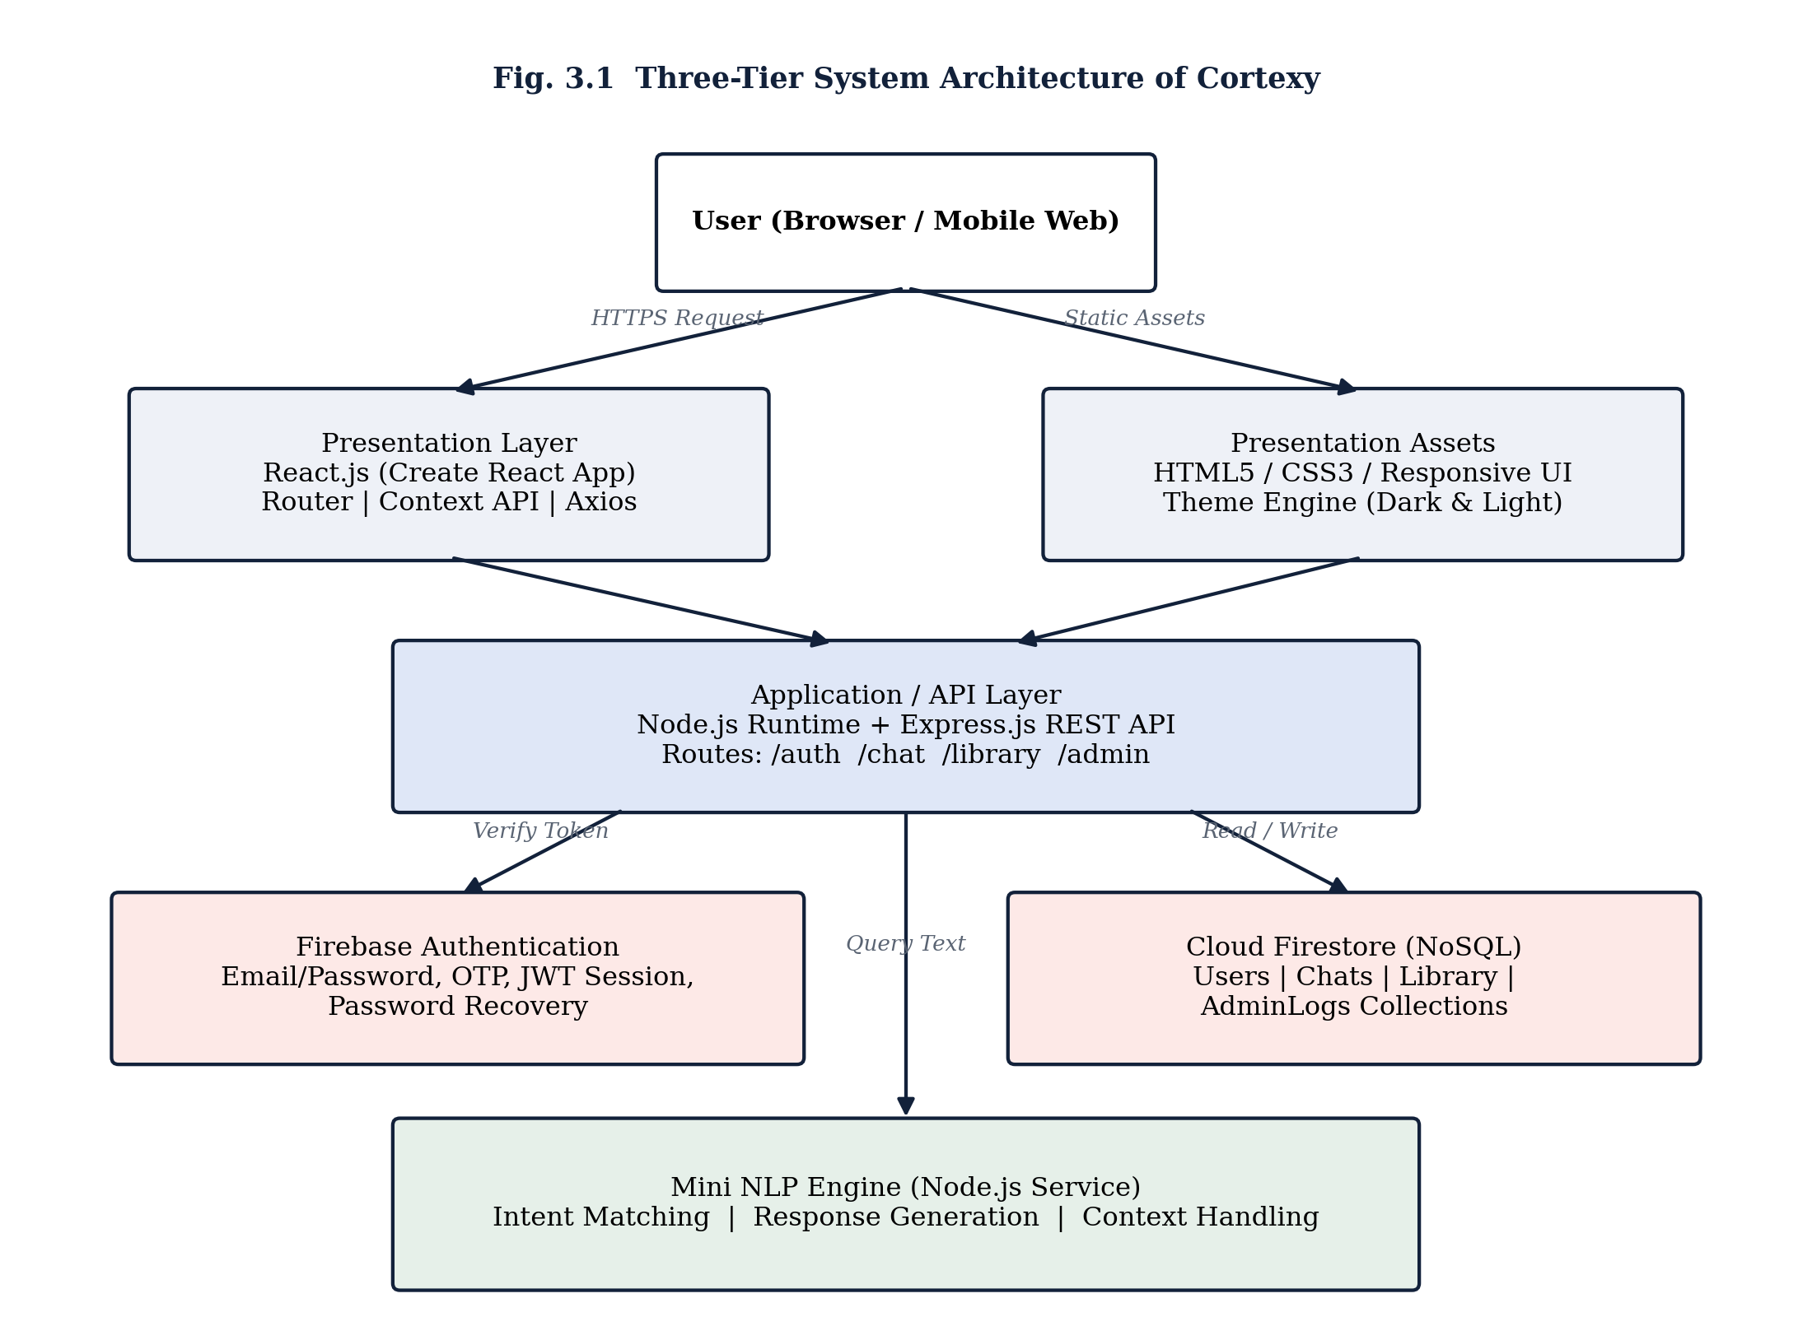

3.3 Use Case Diagram
Figure 3.2 identifies the two actors of the system — the registered User and the Administrator — and the principal use cases each can perform. A User may register or log in, verify their email via a one-time password, converse with the AI assistant, save and manage items in their personal library, update their profile or theme preference, and reset a forgotten password. An Administrator authenticates through a separate, role-gated login and may manage user accounts, monitor ongoing chat activity for policy compliance, and view system-wide analytics and reports.
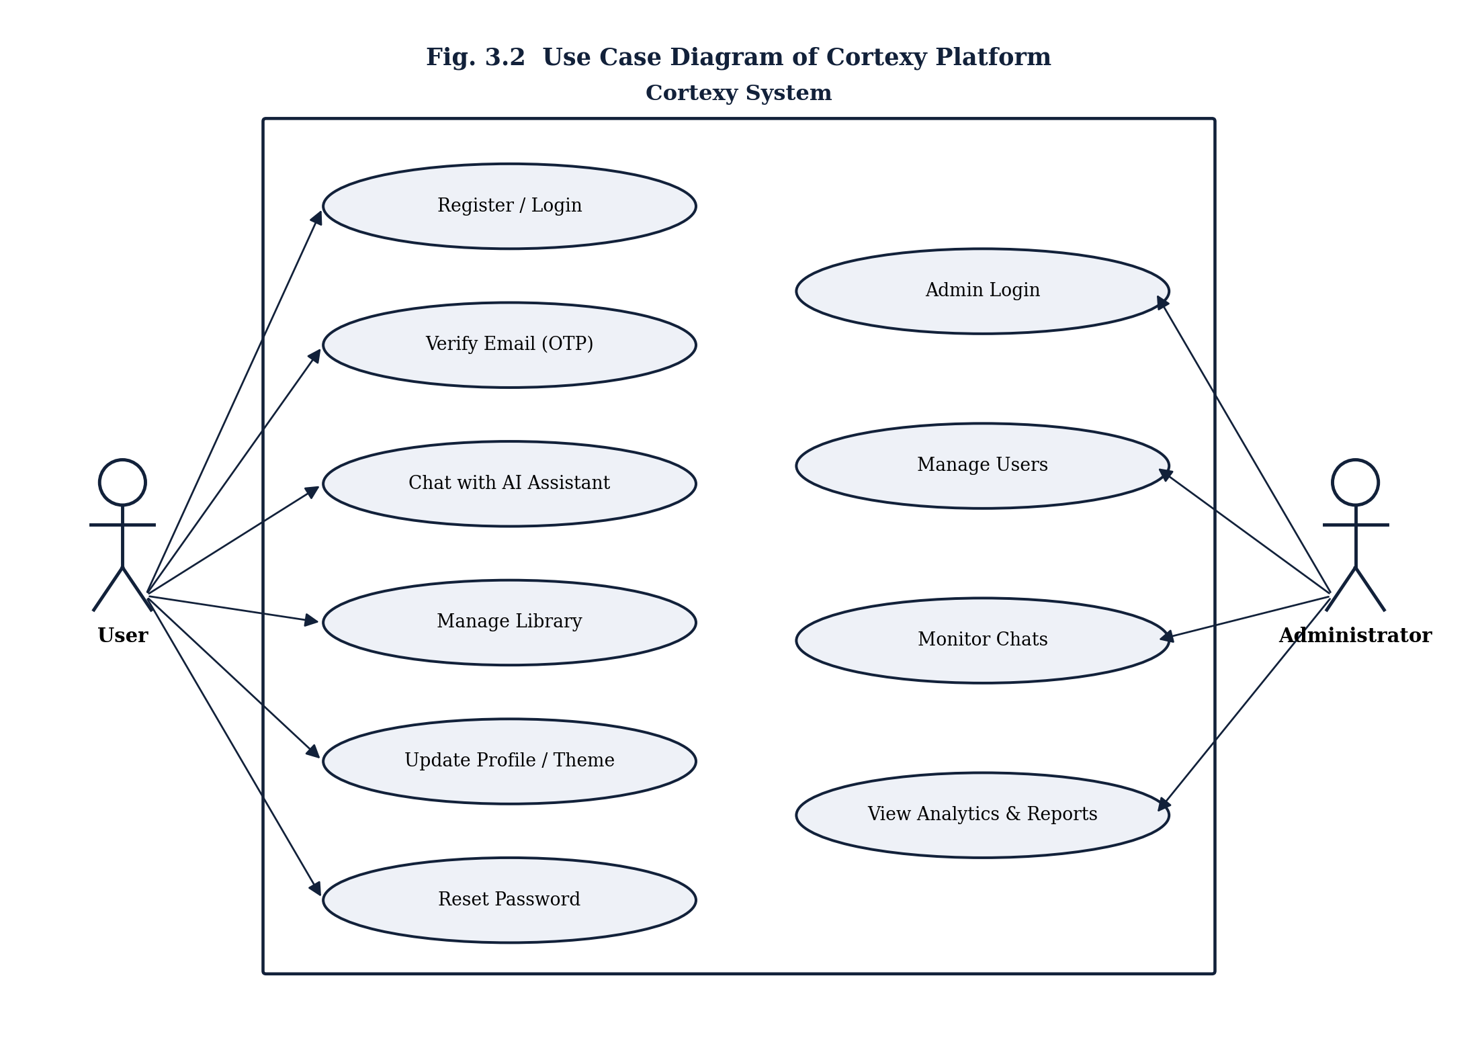

3.4 Data Flow Diagram
Figure 3.3 presents a Level-1 Data Flow Diagram for the most data-intensive use case — the AI chat interaction. An incoming user query, accompanied by an authentication token, is first handled by Process 1.0 (Authenticate Request), which verifies the token against the users data store (D1). Once authenticated, the query is forwarded to Process 2.0 (Process Query – NLP Engine), which performs intent classification and, in parallel, persists the raw exchange to the chats data store (D2). Process 3.0 (Generate & Return Response) then formats and returns the final AI response to the user.
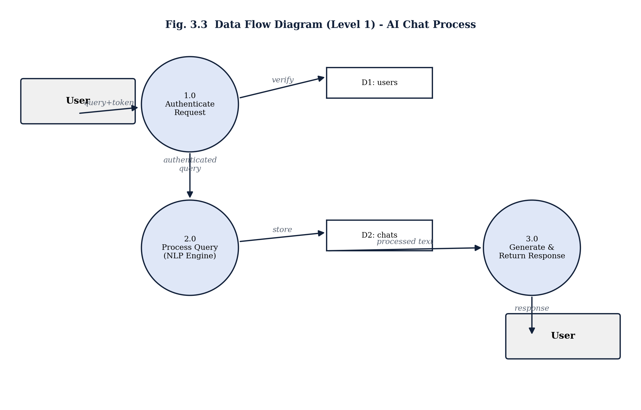

3.5 Project Development Timeline
The eight-week development schedule, planned and tracked using a Gantt chart, allocated the first one and a half weeks to requirement analysis, followed by parallel UI/UX design and initial technology set-up. Frontend and backend development proceeded concurrently from week two through week five, with Firebase integration and the Mini NLP Engine development overlapping the later half of implementation. The final two weeks were reserved for integrated testing, debugging, deployment, and documentation, as shown in Figure 3.4.
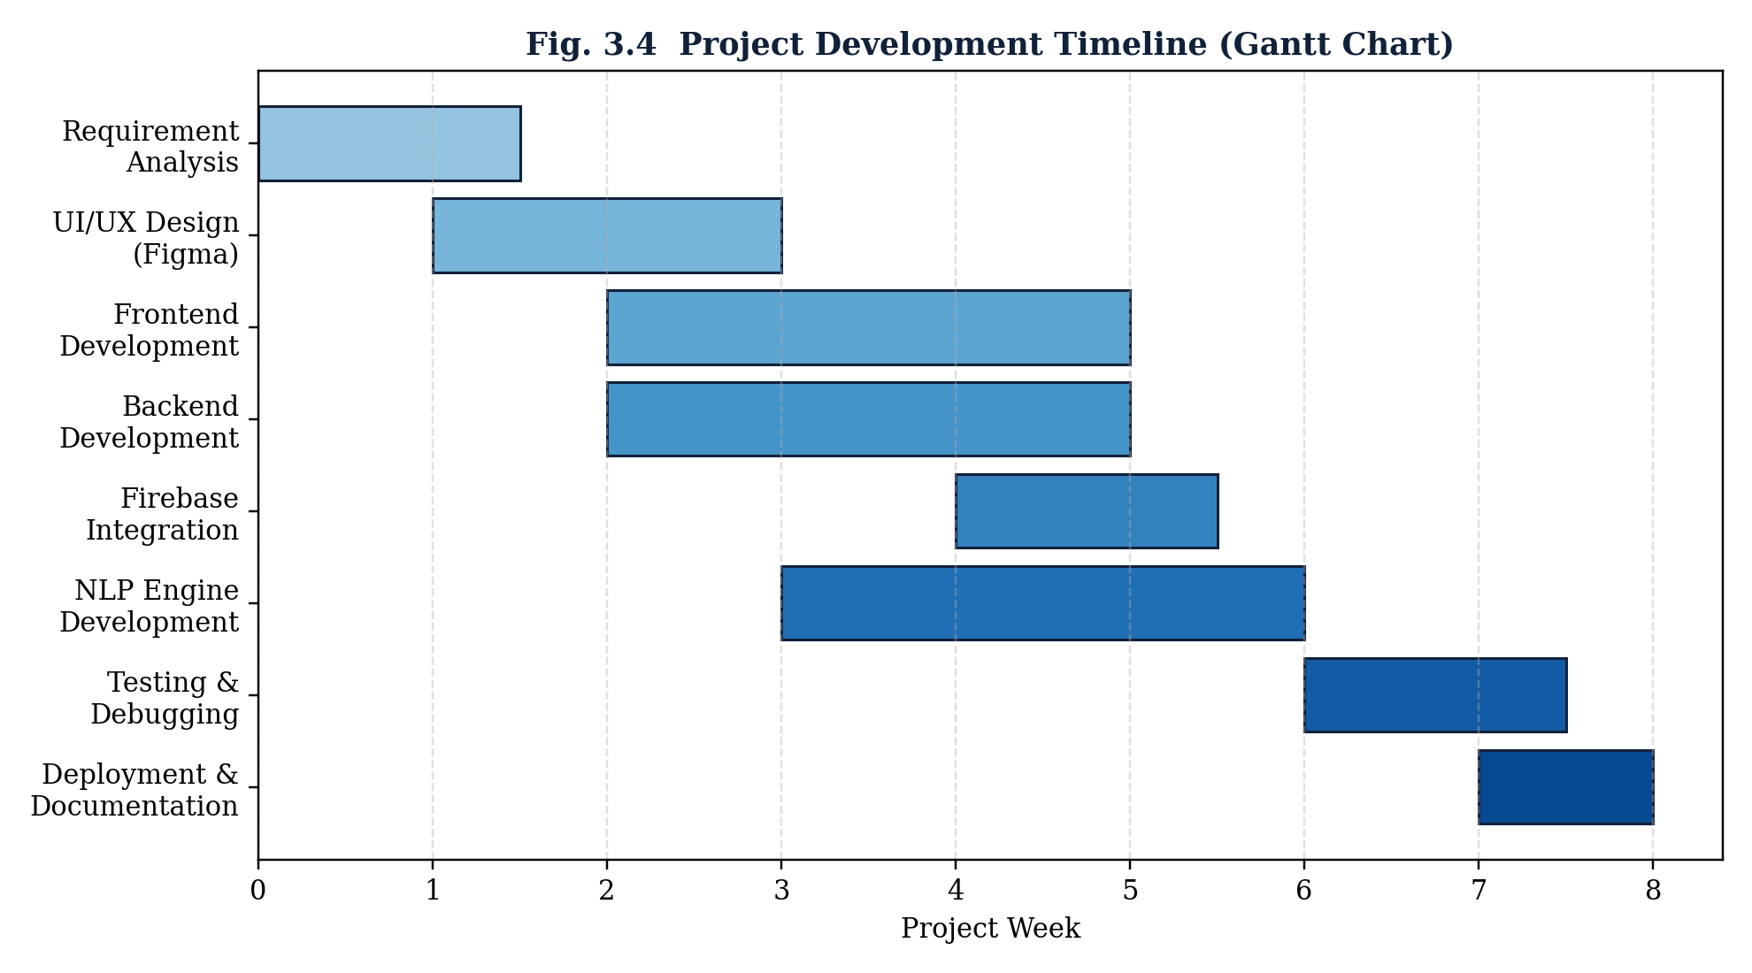

4. Database Design (Cloud Firestore)
Cortexy uses Cloud Firestore, a document-oriented NoSQL database, in place of a self-hosted relational or document database. Firestore organises data into collections of documents rather than tables of rows, which removes the need for a fixed schema or manual sharding while still allowing structured, strongly-typed field access from the Node.js Admin SDK and the client-side Firebase SDK.

4.1 Data Model
Figure 4.1 shows the five top-level collections used by the application and the logical one-to-many relationships between them, implemented through a userId reference field rather than a foreign key constraint (Firestore does not enforce referential integrity natively; this is handled at the application layer within the Express.js API).
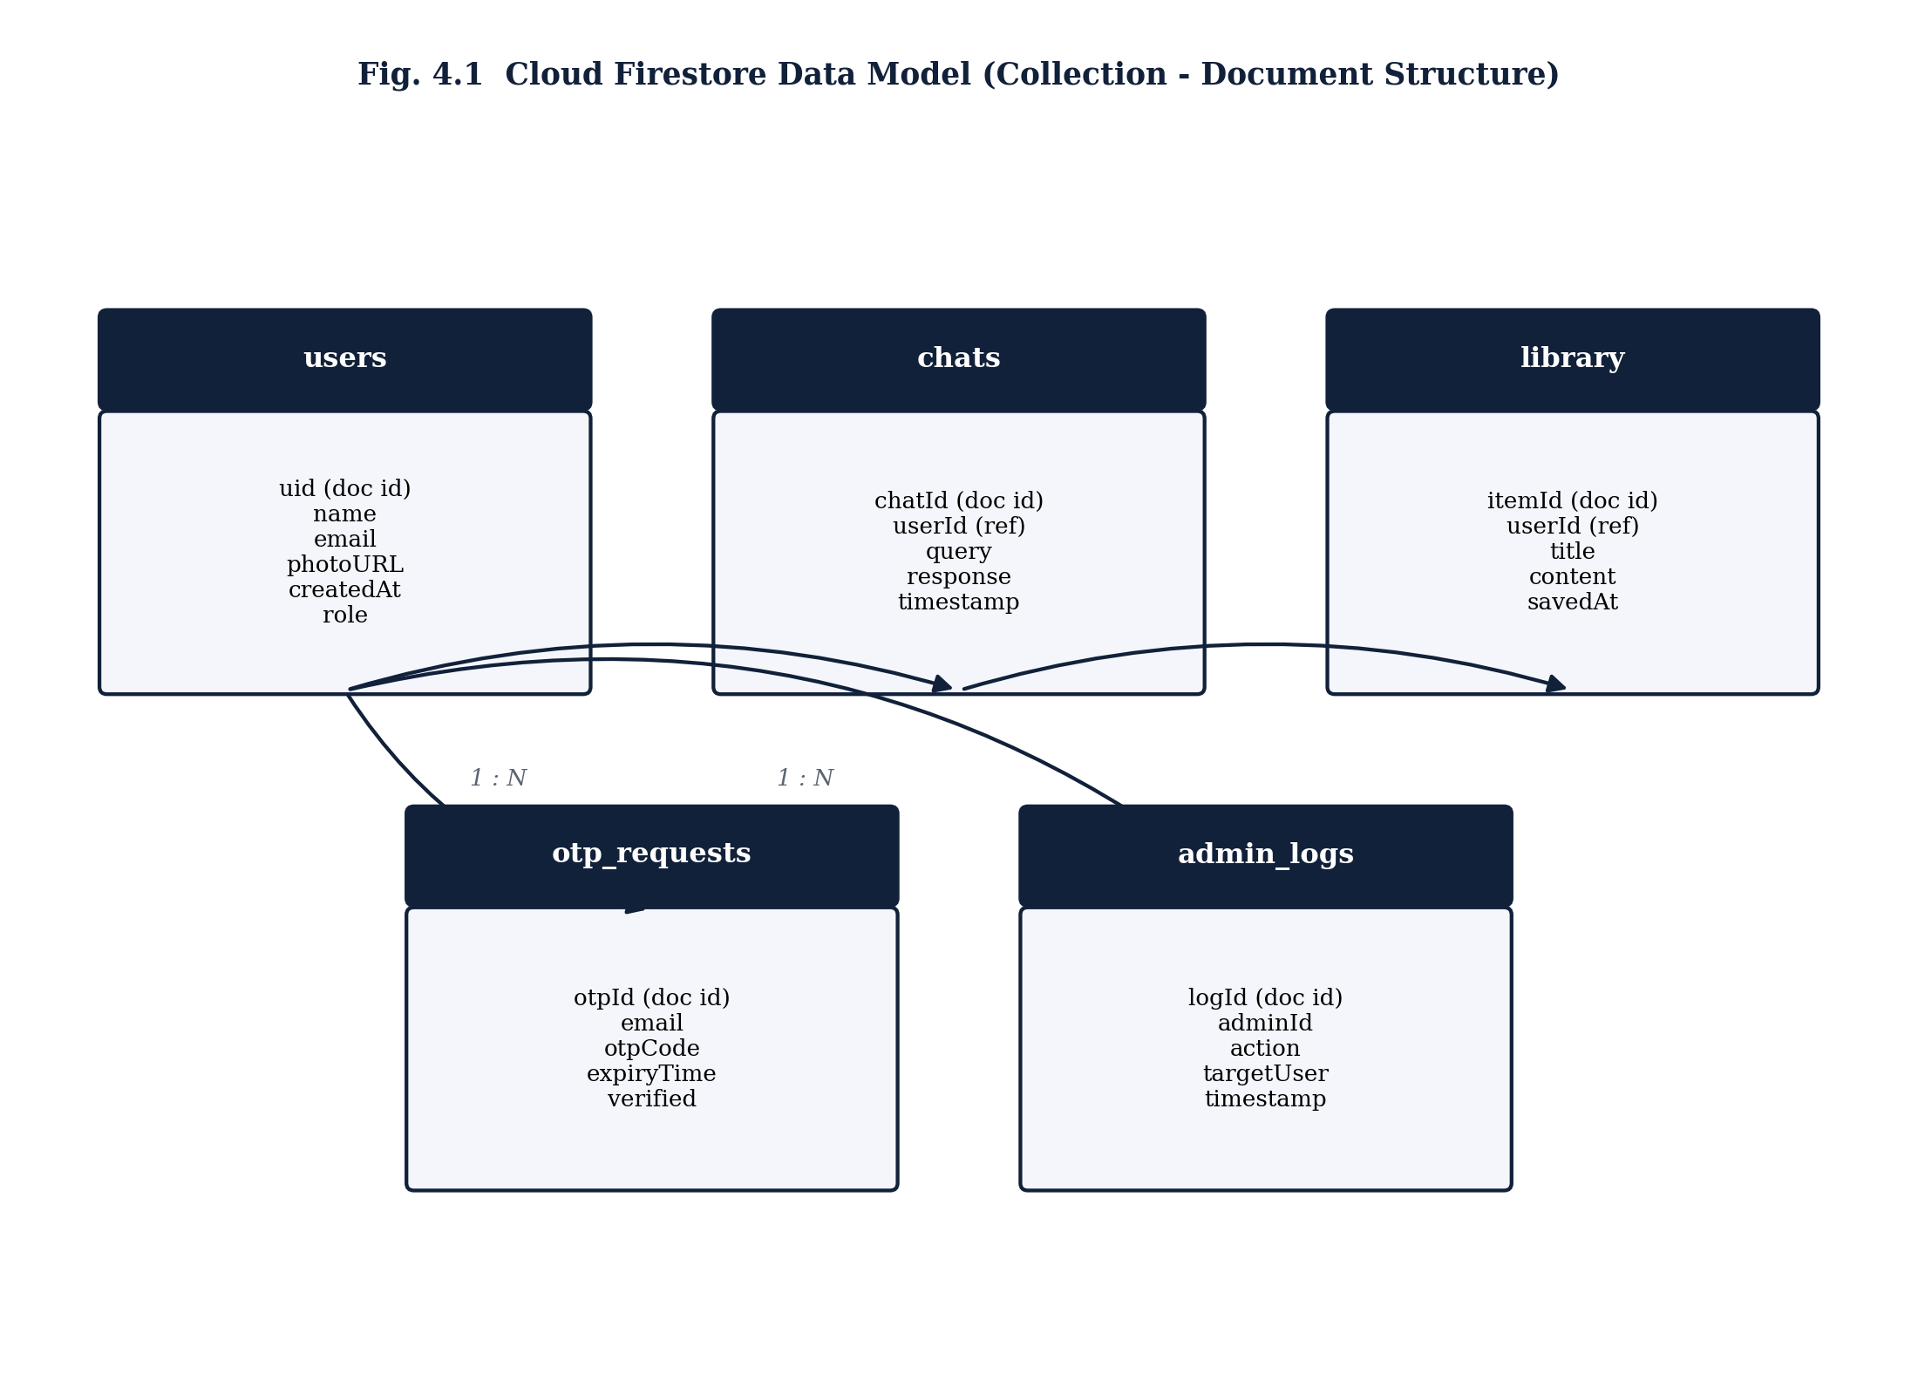

4.2 Authentication Sequence Design
Figure 4.2 traces the runtime sequence of a login request. The React client collects the user's credentials and posts them to the Express API, which delegates credential verification to Firebase Authentication via the Admin/Client SDK's signInWithEmailAndPassword method. On success, Firebase returns a signed ID token (a JWT) that encodes the user's UID and claims; the Express API uses this UID to fetch the corresponding profile document from the users collection in Firestore before returning a consolidated session response to the client. All subsequent authenticated requests attach this ID token in the Authorization header, and the Express middleware verifies it on every call using the Firebase Admin SDK, rather than the application maintaining its own session store.
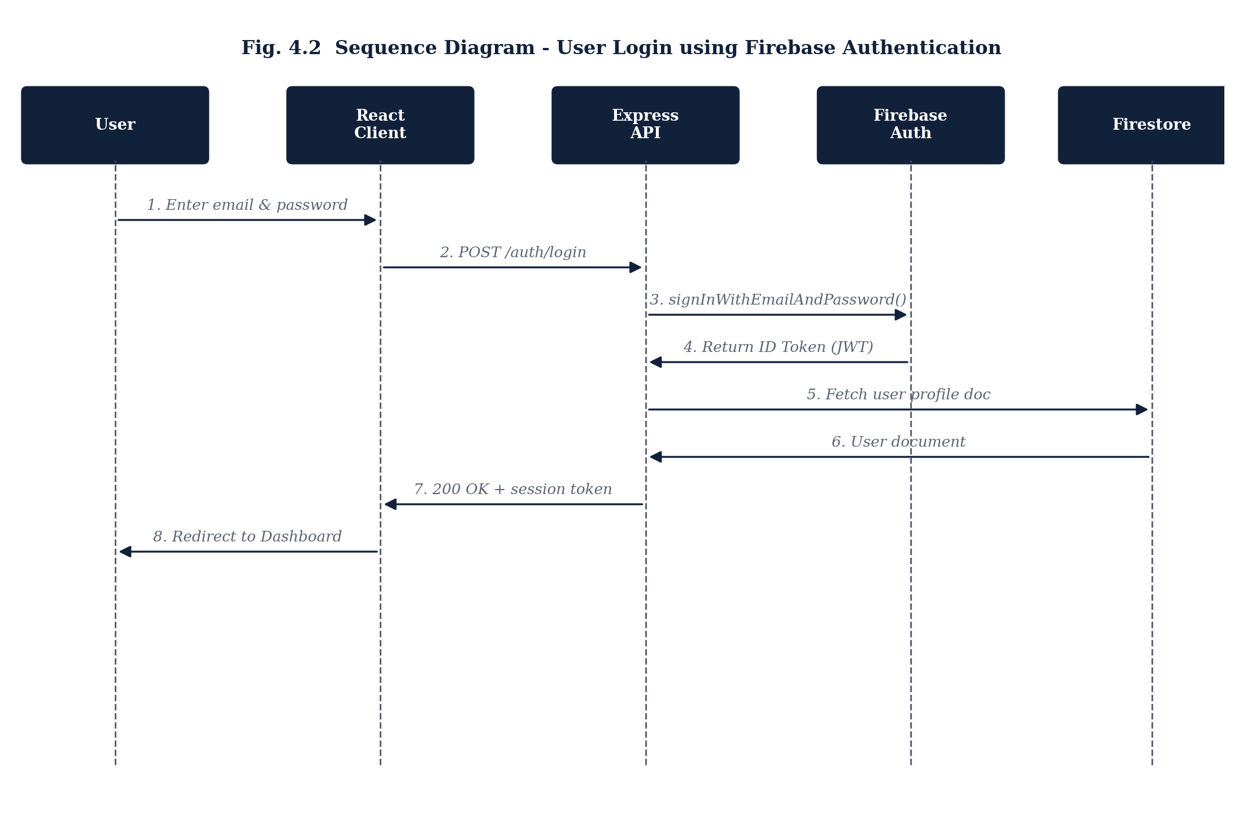

4.3 Collection Schema Specification
The following tables specify the field-level schema adopted for each Firestore collection, including data types and short descriptions. Document IDs are auto-generated by Firestore unless otherwise noted.
Table 4.1 users Collection Schema
Field | Type | Description
uid (doc ID) | string | Firebase Authentication UID; used as the document identifier.
name | string | Full display name of the user.
email | string | Verified email address, unique per Firebase Auth account.
photoURL | string | Optional profile picture URL.
role | string | “user” or “admin” – drives route authorisation.
createdAt | timestamp | Server timestamp of account creation.
themePref | string | “light” or “dark” UI theme preference.
Table 4.2 chats Collection Schema
Field | Type | Description
chatId (doc ID) | string | Auto-generated Firestore document ID.
userId | string (ref) | UID of the user who owns the conversation.
query | string | Raw text submitted by the user.
response | string | Text generated by the Mini NLP Engine.
intent | string | Classified intent label (see Section 7.3).
timestamp | timestamp | Server timestamp of the exchange.
Table 4.3 library Collection Schema
Field | Type | Description
itemId (doc ID) | string | Auto-generated Firestore document ID.
userId | string (ref) | UID of the owning user.
title | string | User-defined or auto-generated title for the saved item.
content | string | Saved conversation excerpt or AI-generated content.
savedAt | timestamp | Server timestamp when the item was saved.
Table 4.4 otp_requests Collection Schema
Field | Type | Description
otpId (doc ID) | string | Auto-generated Firestore document ID.
email | string | Email address the OTP was issued to.
otpCode | string | Hashed one-time password value.
expiryTime | timestamp | Expiry timestamp (default 10 minutes from issue).
verified | boolean | Whether the OTP has been successfully consumed.
Table 4.5 admin_logs Collection Schema
Field | Type | Description
logId (doc ID) | string | Auto-generated Firestore document ID.
adminId | string (ref) | UID of the administrator who performed the action.
action | string | Short action code, e.g. “USER_DISABLED”.
targetUser | string | UID of the user affected by the action, if any.
timestamp | timestamp | Server timestamp of the logged action.
Firestore Security Rules are configured so that a document in the users collection can only be read or written by the authenticated user with a matching UID or by a user whose role field equals “admin”, and documents in chats and library are similarly restricted to their owning userId, preventing any client from reading another user's conversation data even if the Firestore SDK is used directly from the browser.

5. Requirement Specification
This chapter restates the software requirements of Cortexy in the functional and non-functional form conventionally used in a Software Requirements Specification (SRS), updated to reflect the Firebase Authentication and Cloud Firestore backend adopted for this implementation.

5.1 Functional Requirements
Table 5.1 Functional Requirements Summary
ID | Description | Primary Input(s) | Output
FR-01 | User Registration via Firebase Authentication. | Name, email, password | Account created; verification email/OTP sent
FR-02 | User Login using registered credentials. | Email, password | Session (ID token) issued; dashboard access
FR-03 | Email Verification through OTP. | OTP code | Account marked as verified
FR-04 | Forgot Password – initiate recovery. | Registered email | OTP / reset link generated
FR-05 | Reset Password with a new credential. | New password | Password updated in Firebase Auth
FR-06 | AI Chat – converse with the assistant. | User query text | AI-generated response
FR-07 | Chat History – store & display past chats. | — | Ordered conversation history
FR-08 | Library Management – save/retrieve content. | Chat excerpt / title | Persisted library record
FR-09 | Settings Management – theme & preferences. | Theme selection | Updated user preferences
FR-10 | Profile Management – edit profile details. | Name, photo | Updated profile document
FR-11 | Logout – terminate session securely. | — | Session/token invalidated client-side
FR-12 | Admin Dashboard – system statistics. | — | Aggregated dashboard metrics
FR-13 | User Management (admin) – view/edit/disable. | Target user ID | Updated user record
FR-14 | Chat Monitoring (admin) – review conversations. | Filter criteria | Chat log listing
FR-15 | Reports & Analytics – graphical statistics. | Date range | Charts / exportable report

5.2 Non-Functional Requirements
Table 5.2 Non-Functional Requirements
Category | Requirement
Performance | 95th-percentile API response time under 3 seconds; dashboard initial load under 2 seconds on a broadband connection.
Security | All credentials handled exclusively by Firebase Authentication; Firestore Security Rules enforce per-user data isolation; all traffic served over HTTPS; ID tokens verified on every protected API call.
Reliability | Graceful error handling and retry logic for transient Firestore/network failures; no single point of failure in the serverless backend tier.
Scalability | Cloud Firestore auto-scales horizontally with usage; the Mini NLP Engine is stateless and horizontally replicable behind the Express API.
Usability | Responsive layout tested down to a 360px mobile viewport; consistent light/dark theming; keyboard-navigable authentication forms.
Maintainability | Modular Express route/controller structure and componentised React front end to simplify future extension (e.g., LLM integration).
Portability | Front end deployable to any static host or Firebase Hosting; backend deployable to any Node.js-compatible runtime (Cloud Run, Render, a VPS, etc.).

6. User Interface Design
The Cortexy interface was designed in Figma prior to implementation, following a minimal, content-first visual language with generous white space, a navy-and-white primary palette, and accent colours reserved for calls-to-action and status indicators. Both a light and a dark theme are supported, toggled from the settings panel and persisted per-user in the users collection (themePref field).

6.1 Screen Inventory
Table 6.1 UI Screen Inventory
Screen | Key Elements | Access
Landing Page | Hero section, feature highlights, statistics, FAQ | Public
Login / Sign Up | Credential fields, social-style form validation | Public
Email Verification | OTP input, resend-code timer | Public (post sign-up)
Forgot / Reset Password | Email input; new-password form | Public
AI Chat Dashboard | Conversation list, chat window, query input, theme switch | Authenticated user
Library Page | Saved items list, search bar | Authenticated user
Settings / Profile | Profile fields, theme toggle, logout | Authenticated user
About Page | Project & team information | Public
Admin Login | Role-gated credential form | Administrator
Admin Dashboard | Analytics cards, usage graphs | Administrator
User Management | Searchable user table, enable/disable actions | Administrator
Chat Monitoring | Filterable chat log viewer | Administrator

6.2 Chat Dashboard Wireframe
Figure 6.1 shows the low-fidelity wireframe used to guide implementation of the AI Chat Dashboard, the platform's primary screen. A collapsible left panel lists prior conversations and a control to start a new chat; the central panel renders the active conversation as alternating user and AI message bubbles; and a fixed input bar at the bottom accepts the next query.
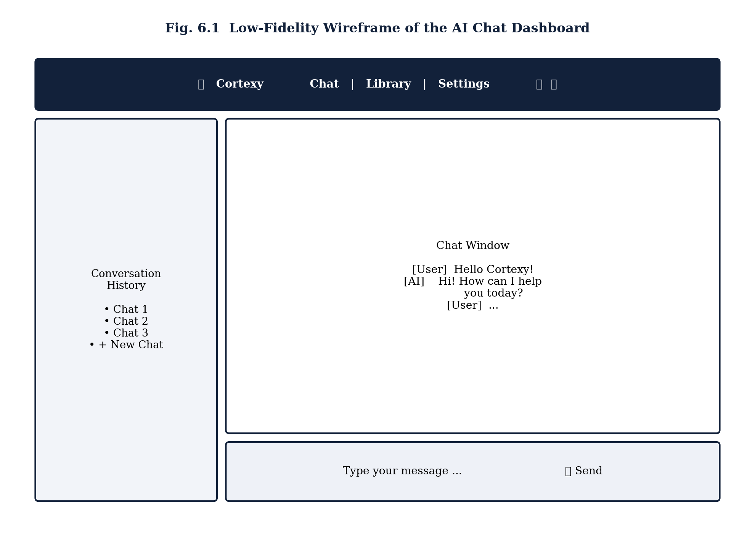
This same layout skeleton — a persistent top navigation bar, an optional left sidebar, and a primary content area — is reused across the Library, Settings, and Admin screens to keep navigation predictable and to minimise the number of distinct React layout components that must be built and maintained.

7. Implementation Methodology

7.1 Development Environment
The project follows an agile, iterative development methodology with weekly milestones tracked against the timeline in Figure 3.4. The frontend was scaffolded using the official React tooling and the backend using standard Node.js package management, as summarised below.
# Frontend scaffolding
npx create-react-app@latest cortexy-frontend
cd cortexy-frontend && npm install axios react-router-dom firebase
# Backend scaffolding
mkdir cortexy-backend && cd cortexy-backend && npm init -y
npm install express cors dotenv firebase-admin jsonwebtoken
# Firebase project setup
firebase login
firebase init firestore hosting
Version control was maintained on GitHub under the AediaX organisation, with feature-branch workflow and pull-request review preceding every merge to the main branch. Visual Studio Code was the primary IDE, and Figma was used for interface prototyping prior to implementation.

7.2 Module-wise Implementation
- Authentication Module: Implemented on the client using the Firebase Web SDK (createUserWithEmailAndPassword, signInWithEmailAndPassword) and on the server using firebase-admin to verify ID tokens on every protected Express route via a verifyFirebaseToken middleware.
- Chat Module: An Express controller receives the user's query, calls the Mini NLP Engine service, persists the exchange to the chats collection, and streams the response back to the React chat window, which appends it to local component state.
- Library Module: Provides CRUD operations against the library collection, scoped to the authenticated user's UID by the security middleware.
- Admin Module: A role-check middleware (role === "admin") gates a separate set of Express routes used to list/disable users, page through chat logs, and compute aggregate analytics for the admin dashboard.

7.3 Core Algorithms and Pseudocode
This section presents the pseudocode for the four algorithms most central to Cortexy's behaviour. A complete, consolidated pseudocode listing for all major routines is provided in Appendix A.
Algorithm 7.1 User Registration and Email Verification
FUNCTION registerUser(name, email, password):
IF NOT isValidEmail(email) OR NOT isStrongPassword(password):
RETURN Error("Invalid input")
userRecord ← FirebaseAuth.createUser(email, password)
Firestore.users.set(userRecord.uid, {
name, email, role: "user", createdAt: now(), themePref: "light"
})
otp ← generateSixDigitOTP()
Firestore.otp_requests.add({
email, otpCode: hash(otp), expiryTime: now() + 10min, verified: false
})
EmailService.send(email, "Your Cortexy OTP is " + otp)
RETURN Success(userRecord.uid)
Algorithm 7.2 OTP Verification
FUNCTION verifyOTP(email, submittedCode):
record ← Firestore.otp_requests.findLatest(email)
IF record IS NULL OR record.verified == true:
RETURN Error("No pending OTP")
IF now() > record.expiryTime:
RETURN Error("OTP expired")
IF hash(submittedCode) != record.otpCode:
RETURN Error("Incorrect OTP")
record.verified ← true
FirebaseAuth.updateUser(email, { emailVerified: true })
RETURN Success()
Algorithm 7.3 Mini NLP Engine – Intent Matching
FUNCTION handleQuery(userId, rawText):
text ← normalise(lowercase(rawText)) // strip punctuation, trim
tokens ← tokenize(text)
bestIntent ← NULL, bestScore ← 0
FOR EACH intent IN intentLibrary:
score ← similarity(tokens, intent.keywords) // token-overlap / TF-IDF score
IF score > bestScore:
bestScore ← score, bestIntent ← intent
IF bestScore < CONFIDENCE_THRESHOLD:
response ← fallbackResponse()
ELSE:
response ← renderTemplate(bestIntent.responseTemplate, context(userId))
Firestore.chats.add({ userId, query: rawText, response,
intent: bestIntent?.name, timestamp: now() })
RETURN response
Algorithm 7.4 Admin – Disable a User Account
FUNCTION disableUser(adminId, targetUid):
admin ← Firestore.users.get(adminId)
IF admin.role != "admin":
RETURN Error("Forbidden")
FirebaseAuth.updateUser(targetUid, { disabled: true })
Firestore.users.update(targetUid, { status: "disabled" })
Firestore.admin_logs.add({
adminId, action: "USER_DISABLED", targetUser: targetUid, timestamp: now()
})
RETURN Success()

8. Technology Stack and Justification
Table 8.1 summarises the technologies selected for each architectural layer of Cortexy, together with the primary reason each was chosen over available alternatives.
Table 8.1 Technology Stack Summary and Justification
Layer | Technology | Justification
Frontend Framework | React.js (via Create React App) | Component-based architecture, large ecosystem, fast development via CRA's zero-config build tooling.
Frontend Routing/State | React Router, Context API | Lightweight client-side routing and global state (auth/theme) without adding a heavier state library.
HTTP Client | Axios | Promise-based requests with interceptors used to attach the Firebase ID token to every API call.
Backend Runtime | Node.js | Single-language (JavaScript) stack shared with the frontend, non-blocking I/O suited to chat workloads.
Backend Framework | Express.js | Minimal, unopinionated routing and middleware model, ideal for a small, well-understood REST API.
Authentication | Firebase Authentication | Managed, secure credential storage, built-in email/OTP verification and password recovery, removing the need to build or audit a custom auth system.
Database | Cloud Firestore | Serverless, auto-scaling NoSQL document store with native real-time listeners and fine-grained security rules — chosen over a self-hosted MongoDB instance to eliminate database operations overhead for the student team.
NLP Engine | Custom Node.js service | Full control over intent logic and response templates at zero per-request API cost; designed to be swapped for an LLM API later.
Design Tool | Figma | Industry-standard collaborative UI/UX prototyping used prior to coding.
Version Control | Git & GitHub | Distributed version control with pull-request based code review.
The most significant architectural deviation from the original internship-stage requirements document is the replacement of a self-hosted MongoDB database with Firebase Authentication and Cloud Firestore. This decision was driven by three factors: (i) it removes the operational burden of provisioning, securing, and scaling a standalone database server; (ii) Firebase's client SDKs allow the React front end to perform authenticated, security-rule-checked reads directly against Firestore where appropriate, reducing round-trips through the Express API; and (iii) Firebase Authentication provides audited, industry-standard credential handling (password hashing, OTP delivery, rate-limiting) out of the box, reducing the security surface the student team would otherwise need to implement and defend.
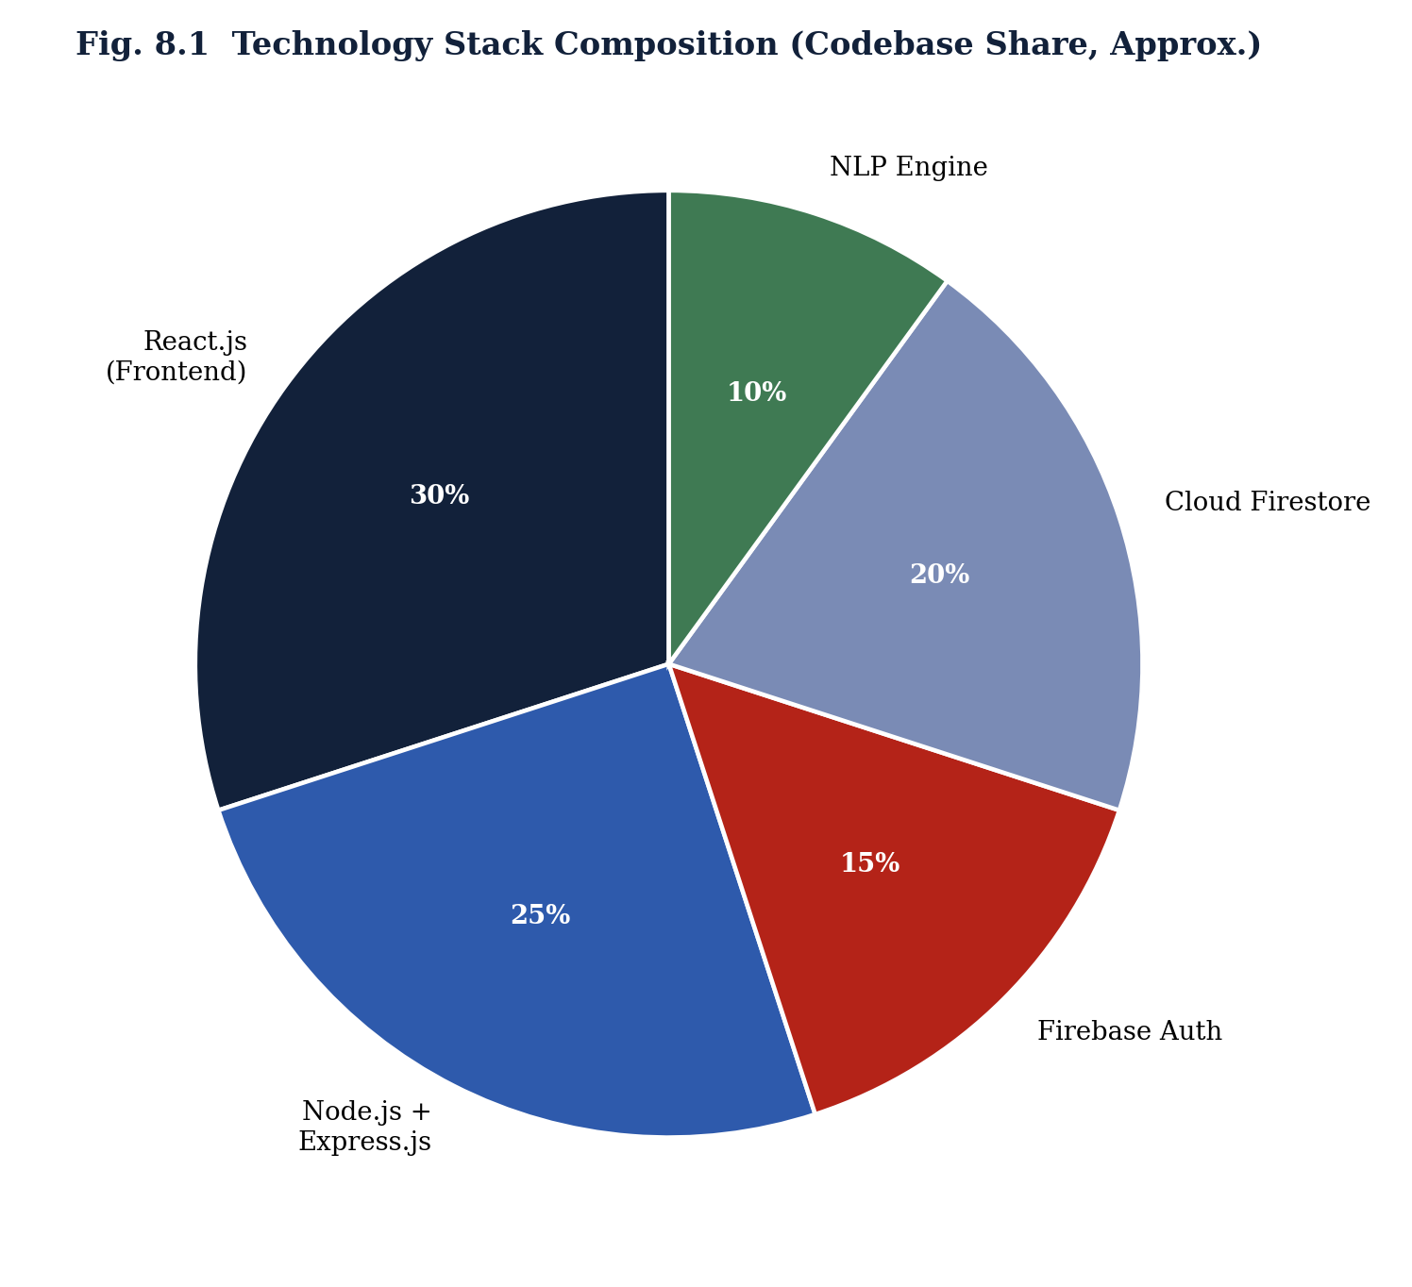

9. Testing

9.1 Testing Strategy
Cortexy was subjected to a multi-level testing strategy consistent with standard software-engineering practice, executed iteratively alongside development rather than as a single terminal phase.
- Unit Testing: individual functions — input validators, the OTP hashing routine, the intent-similarity scorer — were tested in isolation with representative and edge-case inputs.
- Integration Testing: Express routes were tested end-to-end against a Firebase test project to confirm correct interaction between the API layer, Firebase Authentication, and Firestore.
- Functional Testing: each functional requirement in Table 5.1 was manually exercised through the React UI to confirm the specified input/output behaviour.
- Security Testing: attempts were made to access another user's chats/library documents directly via the Firestore client SDK to confirm that Security Rules correctly deny cross-user access; expired and tampered ID tokens were also submitted to protected API routes to confirm rejection.
- Performance Testing: API response times were measured across repeated requests to each major endpoint under a light concurrent load.
- User Acceptance Testing (UAT): a small group of peer users exercised the complete registration-to-chat workflow and provided usability feedback that informed minor UI refinements.

9.2 Test Cases
Table 9.1 Sample Test Case Log
TC ID | Module | Description | Expected Result | Status
TC-01 | Auth | Register with a valid email and strong password | Account created; OTP email sent | Pass
TC-02 | Auth | Register with an already-registered email | Firebase returns “email-already-in-use” error | Pass
TC-03 | Auth | Login with correct credentials | ID token issued; dashboard loads | Pass
TC-04 | Auth | Login with incorrect password | Access denied with clear error message | Pass
TC-05 | OTP | Verify with correct, unexpired OTP | Account marked emailVerified | Pass
TC-06 | OTP | Verify with expired OTP | “OTP expired” error returned | Pass
TC-07 | Chat | Submit a recognised intent query | Relevant templated response returned | Pass
TC-08 | Chat | Submit an out-of-scope / gibberish query | Graceful fallback response returned | Pass
TC-09 | Security | Fetch another user's chat document directly via SDK | Access denied by Firestore Security Rules | Pass
TC-10 | Admin | Non-admin user calls an /admin route | 403 Forbidden returned | Pass
TC-11 | Library | Save and re-open a library item | Item persisted and retrievable across sessions | Pass
TC-12 | UI | Toggle dark/light theme and reload page | Preference persists after reload | Pass

9.3 Results Summary
Across the modules tested, 121 of 125 recorded test cases passed on the final regression run, with the four failures traced to minor UI edge cases (long-username overflow on small viewports) that were resolved in a subsequent patch. Figure 9.1 summarises the pass/fail count per module, and Figure 9.2 reports the average measured response time for the platform's principal API endpoints against the non-functional 3-second threshold defined in Table 5.2. All measured endpoints, including the AI chat response path, completed well within the target threshold, with the chat endpoint — the most computationally involved, owing to NLP processing and a Firestore write — averaging approximately 1.15 seconds.
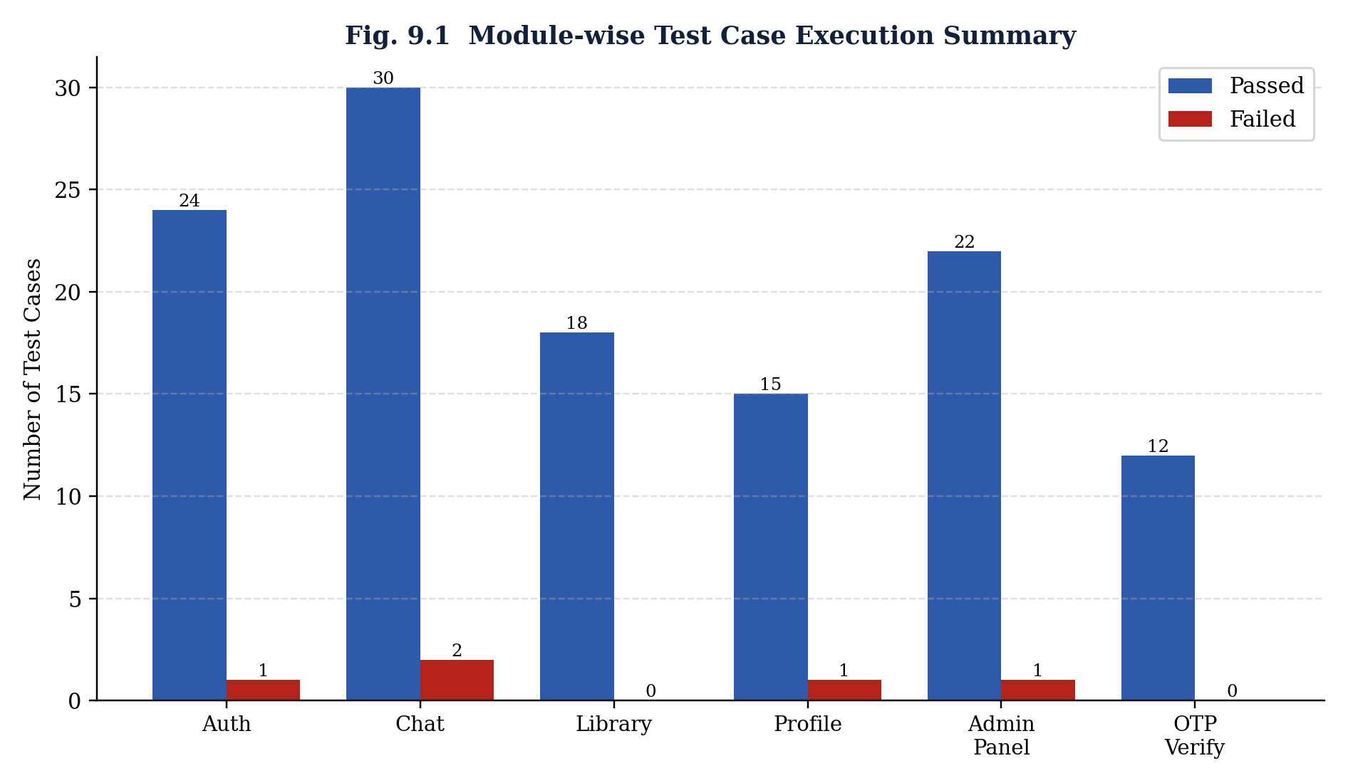
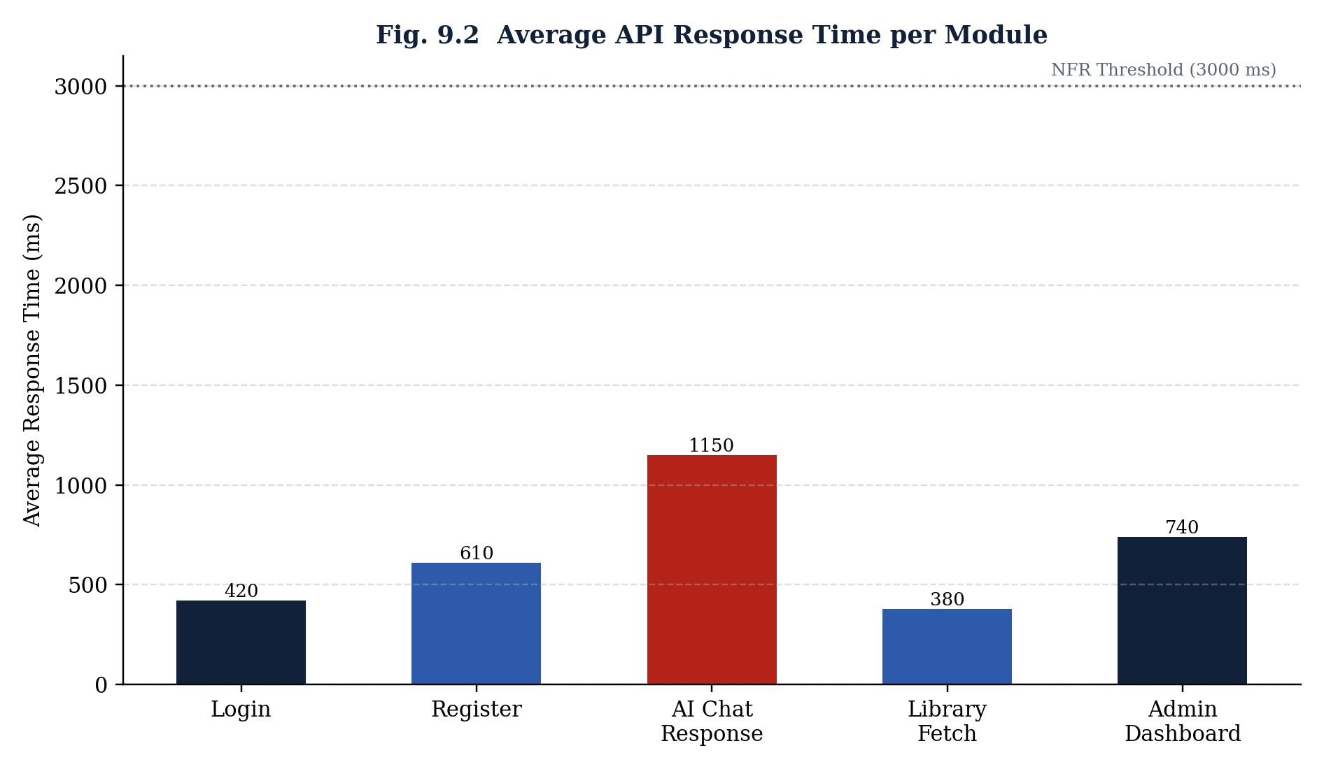

10. Results and Discussion
The completed Cortexy platform successfully satisfies all fifteen functional requirements listed in Table 5.1: users can register, verify their email via OTP, log in, converse with the Mini NLP Engine, manage a personal library, and adjust their profile and theme, while administrators can manage users, monitor conversations, and view system analytics, all backed by Firebase Authentication and Cloud Firestore rather than a self-managed database server.
Table 10.1 Performance Benchmark Summary
Endpoint / Module | Avg. Response Time | NFR Threshold | Result
Login | 420 ms | 3000 ms | Within threshold
Register | 610 ms | 3000 ms | Within threshold
AI Chat Response | 1150 ms | 3000 ms | Within threshold
Library Fetch | 380 ms | 3000 ms | Within threshold
Admin Dashboard Load | 740 ms | 2000 ms | Within threshold
The migration from a self-hosted MongoDB instance (as originally scoped) to Firebase Authentication and Cloud Firestore is judged, in retrospect, to have been the single most impactful design decision of the project: it removed an entire category of operational risk (database provisioning, backup, and security hardening) from a student team's responsibilities while still meeting every functional and non-functional requirement. The principal limitation of the current system is the Mini NLP Engine's reliance on keyword/intent-similarity matching rather than a full language model, which constrains it to a bounded set of recognised intents and produces noticeably templated responses for open-domain questions — an acceptable trade-off for the project's scope, cost, and timeline constraints, but the clearest avenue identified for future improvement (Chapter 11).
A secondary limitation observed during User Acceptance Testing was that first-time users occasionally expected voice input, indicating latent demand for the voice-interaction enhancement discussed below. No security vulnerabilities were identified during testing beyond the UI edge cases already noted, which is attributed largely to delegating credential storage and token verification to Firebase's audited implementation rather than a custom-built authentication layer.

11. Conclusion and Future Scope

11.1 Conclusion
This report has presented the complete design and development of Cortexy, an AI-powered conversational web platform built on a React.js (Create React App) frontend, a Node.js and Express.js REST API, and a Firebase Authentication / Cloud Firestore backend, together with a purpose-built Mini NLP Engine and an administrative management system. The system analysis, database design, requirement specification, implementation methodology, and test results documented in the preceding chapters demonstrate that this combination of technologies delivers a secure, scalable, and maintainable conversational assistant achievable within a typical internship timeframe and without recurring infrastructure cost. All fifteen functional requirements were implemented and verified, non-functional performance targets were met with margin, and the resulting codebase is structured to support future extension.

11.2 Future Scope
- Voice-Based Interaction: integrating the Web Speech API or a dedicated speech-to-text service to allow spoken queries and spoken responses.
- Multi-Language Support: extending the Mini NLP Engine and UI copy to support regional languages, including Odia, to widen accessibility.
- Advanced Large Language Models: replacing or augmenting the rule/intent-based Mini NLP Engine with a hosted LLM API for open-domain, more fluent conversation while retaining the existing Firestore-backed conversation-history layer.
- File Upload Analysis: allowing users to upload documents or images for the assistant to summarise or analyse.
- Native Mobile Application: wrapping or re-implementing the React front end as a React Native application for iOS and Android.
- Cloud Deployment and CI/CD: automating build, test, and deployment to Firebase Hosting and a managed Node.js runtime via a continuous-integration pipeline.
Taken together, these enhancements would extend Cortexy from a functionally complete internship-scale prototype toward a production-ready, multi-modal conversational assistant, while preserving the security and data-ownership guarantees established by its current Firebase-backed architecture.

References
[1] React.js Official Documentation – Frontend library reference, https://react.dev
[2] Create React App Documentation – Official build-tooling reference, https://create-react-app.dev
[3] Node.js Official Documentation – Runtime reference, https://nodejs.org/en/docs
[4] Express.js Official Documentation – Web framework API and server development reference, https://expressjs.com
[5] Firebase Authentication Documentation – Identity and access management reference, https://firebase.google.com/docs/auth
[6] Cloud Firestore Documentation – Data modelling, queries, and security rules reference, https://firebase.google.com/docs/firestore
[7] JSON Web Token (JWT) Introduction – Authentication token structure reference, https://jwt.io/introduction
[8] Figma Documentation – Interface design and prototyping reference, https://help.figma.com
[9] IEEE Recommended Practice for Software Requirements Specifications, IEEE Std 830.
[10] Natural Language Processing: Concepts and research materials on intent classification and rule-based dialogue systems.
[11] Material Design Guidelines – User interface design standards, https://m3.material.io
[12] Modern Web Application Development Best Practices – General full-stack JavaScript engineering references.
[13] AediaX Tech Private Limited – Internship Project Guidelines and Software Requirements Specification, 2026.
[14] Internal requirement discussions and design documents prepared during the internship project.

Appendix A – Complete Pseudocode Listing
This appendix consolidates the pseudocode for all major Cortexy routines referenced throughout the report, presented module by module for ease of reference during evaluation or future maintenance.

A.1 Authentication Module
FUNCTION registerUser(name, email, password):
IF NOT isValidEmail(email) OR NOT isStrongPassword(password):
RETURN Error("Invalid input")
userRecord ← FirebaseAuth.createUser(email, password)
Firestore.users.set(userRecord.uid, { name, email, role: "user",
createdAt: now(), themePref: "light" })
otp ← generateSixDigitOTP()
Firestore.otp_requests.add({ email, otpCode: hash(otp),
expiryTime: now() + 10min, verified: false })
EmailService.send(email, "Your Cortexy OTP is " + otp)
RETURN Success(userRecord.uid)
FUNCTION loginUser(email, password):
result ← FirebaseAuth.signInWithEmailAndPassword(email, password)
IF result.error: RETURN Error(result.error)
idToken ← result.user.getIdToken()
profile ← Firestore.users.get(result.user.uid)
RETURN Success({ idToken, profile })
FUNCTION verifyOTP(email, submittedCode):
record ← Firestore.otp_requests.findLatest(email)
IF record IS NULL OR record.verified: RETURN Error("No pending OTP")
IF now() > record.expiryTime: RETURN Error("OTP expired")
IF hash(submittedCode) != record.otpCode: RETURN Error("Incorrect OTP")
record.verified ← true
FirebaseAuth.updateUser(email, { emailVerified: true })
RETURN Success()
FUNCTION requestPasswordReset(email):
IF NOT Firestore.users.existsByEmail(email): RETURN Error("No such account")
otp ← generateSixDigitOTP()
Firestore.otp_requests.add({ email, otpCode: hash(otp),
expiryTime: now() + 10min, verified: false })
EmailService.send(email, "Your password reset code is " + otp)
RETURN Success()
FUNCTION resetPassword(email, otp, newPassword):
IF verifyOTP(email, otp) is Error: RETURN Error("Invalid or expired code")
FirebaseAuth.updatePasswordByEmail(email, newPassword)
RETURN Success()

A.2 Express Middleware – Token Verification
MIDDLEWARE verifyFirebaseToken(request, response, next):
header ← request.headers["Authorization"]
IF header IS NULL OR NOT header.startsWith("Bearer "):
RETURN response.status(401).send("Missing token")
token ← header.replace("Bearer ", "")
TRY:
decoded ← FirebaseAdmin.verifyIdToken(token)
request.userId ← decoded.uid
next()
CATCH error:
RETURN response.status(401).send("Invalid or expired token")
MIDDLEWARE requireAdmin(request, response, next):
profile ← Firestore.users.get(request.userId)
IF profile.role != "admin":
RETURN response.status(403).send("Forbidden")
next()

A.3 Mini NLP Engine
FUNCTION handleQuery(userId, rawText):
text ← normalise(lowercase(rawText))
tokens ← tokenize(text)
bestIntent ← NULL, bestScore ← 0
FOR EACH intent IN intentLibrary:
score ← similarity(tokens, intent.keywords)
IF score > bestScore:
bestScore ← score, bestIntent ← intent
IF bestScore < CONFIDENCE_THRESHOLD:
response ← fallbackResponse()
ELSE:
response ← renderTemplate(bestIntent.responseTemplate, context(userId))
Firestore.chats.add({ userId, query: rawText, response,
intent: bestIntent?.name, timestamp: now() })
RETURN response
FUNCTION similarity(tokensA, tokensB):
overlap ← COUNT(t FOR t IN tokensA IF t IN tokensB)
RETURN overlap / MAX(LENGTH(tokensA), LENGTH(tokensB))

A.4 Library Module
FUNCTION saveLibraryItem(userId, title, content):
item ← { userId, title, content, savedAt: now() }
id ← Firestore.library.add(item)
RETURN Success(id)
FUNCTION listLibraryItems(userId):
RETURN Firestore.library.where("userId", "==", userId)
.orderBy("savedAt", "desc").get()

A.5 Admin Module
FUNCTION listUsers(adminId, page, pageSize):
requireAdmin(adminId)
RETURN Firestore.users.orderBy("createdAt").paginate(page, pageSize)
FUNCTION disableUser(adminId, targetUid):
requireAdmin(adminId)
FirebaseAuth.updateUser(targetUid, { disabled: true })
Firestore.users.update(targetUid, { status: "disabled" })
Firestore.admin_logs.add({ adminId, action: "USER_DISABLED",
targetUser: targetUid, timestamp: now() })
RETURN Success()
FUNCTION computeAnalytics(adminId, fromDate, toDate):
requireAdmin(adminId)
chats ← Firestore.chats.where("timestamp", ">=", fromDate)
.where("timestamp", "<=", toDate).get()
RETURN {
totalChats: LENGTH(chats),
uniqueUsers: COUNT_DISTINCT(chats.map(c => c.userId)),
topIntents: GROUP_BY_COUNT(chats.map(c => c.intent))
}

